Chloe Lang

Professor Nelson

Data Exploration & Deterministic Functions

September 26, 2021

1.

../../../../../Desktop/environmental_data/assignments/Data%20Exploration/Terrain%20Histograms.

2. There is a good amount of variety of elevations of sampling sites. The graph shows an increase in frequency of elevations around 300 to 425 m of elevation; indicating there are an increased number of sampling sites with an elevation in that range. There is a variety in the sites with some only being 100-200 m, and some reaching levels of 800 m. The graph is showing to be skewed to the left. This indicates that there is higher frequency of lower elevation sampling sites in comparison to higher elevation sampling sites. From this graph, we can estimate that the majority of sampling sites are under 400 m of elevation.

3. Slope in this data set is a numeric value. It is representing the slope percentage which is displayed through a numerical value, such as “75” or “80”.

4. According to this histogram of slope at sampling sites, the majority of the sites are on some slope/incline, leaving only a small number of sites being flat or close to flat. There is only a small curve in the shape of the histogram, indicating that there is a somewhat even distribution of slope between the sites. This can be seen by looking at the frequencies of slope percentage from 30% to 80%. They are almost the same in frequency. The histogram is right skewed, showing that there is a greater frequency in smaller slopes than there are for sleep, or high percentage slopes. For example, the majority of the data is at 70% slope or less, indicating there are very few sampling sites above a 70% incline.

5. (I believe) the Aspect is identifying the direction that the downhill slope faces. That is why this variable is measured in degrees from 0-360. This is indicating you are measuring data on the orientation of the downhill slope of the sample site. Zero or 360 indicate the slope is pointing due north.

6. The histogram created of aspect frequency at the sampling sites shows the frequency being fairly evenly distributed among the sites. This indicates that the slopes are facing and equal amount of all directions of earth (N, S,E,W). A northern slope is indicated at either 0 degrees or 360 degrees and a southern slope is indicated at being around 180 degrees. I am guessing with the steep drop off in frequency from 350-400 that the northern degrees would be indicated at 0 degrees rather than 360 degrees. With this thinking, the frequency is showing there is roughly an even amount of north and south facing slopes. Aspect around 200 degrees is slightly lower than at zero degrees, indicating there may be a slightly higher frequency of north facing slopes than south facing slopes.

7.

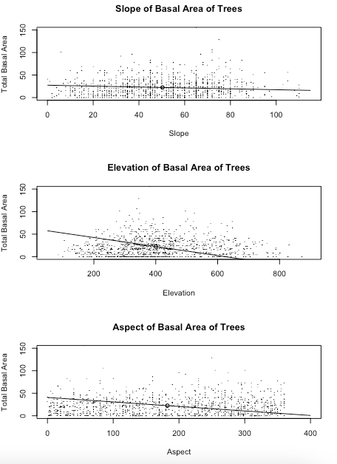

8.

Slope-For the slope variable, it does not appear for there to be an assocatio between increase in slope and total basal area. The linear model I chose is a somewhat good fit as it is mostly a horizontal line, indicating that there is no strong relationship or correlation between the two variables.

Elevation- The elevation terrain shows a somewhat negative association between elevation height and total basal area of trees. This could indicate a linear relationship that suggests a negative correlation between increase and elevation and decrease of total basal area of trees. My line is not the best fit; ideally, I would make the slope smaller to better fit the data.

Aspect- The aspect unfortunately does not show a trend between aspect degree and total basal area. This is expected due to aspect being a circular type of data collection, so a scatterplot may not be the best representation for this data. I did not see a linear trend in the data. My line of fit did not accurately represent the data.

CODE

# Creating a historgram

hist(dat\_habitat$slope)

hist(dat\_habitat$slope,

main = "Histogram of Slope",

xlab="Slope")

hist(dat\_habitat$aspect,

main = "Histogram of Sampling Site Aspect",

xlab = "Aspect")

hist(dat\_habitat$elev,

main = "Histogram of Sampling Site Elevation",

xlab = "Elevation")

# Placing histograms into one figure

par(mfrow=c(3,1))

hist(dat\_habitat$elev,

main = "Histogram of Sampling Site Elevation",

xlab = "Elevation")

hist(dat\_habitat$aspect,

main = "Histogram of Sampling Site Aspect",

xlab = "Aspect")

hist(dat\_habitat$slope,

main = "Histogram of Slope",

xlab="Slope")

# Creating scatterplots of total basal area for each of the terrain variables

plot(dat\_habitat$ba.tot ~ dat\_habitat$slope,

main="Slope of Basal Area of Trees",

xlab= "Slope",

ylab= "Total Basal Area")

plot(dat\_habitat$ba.tot ~ dat\_habitat$elev,

main= "Elevation of Basal Area of Trees",

xlab= "Elevation",

ylab= "Total Basal Area")

plot(dat\_habitat$ba.tot ~ dat\_habitat$aspect,

main= "Aspect of Basal Area of Trees",

xlab="Aspect",

ylab="Total Basal Area")

# Placing scatterplots into one figure with linear line

par(mfrow=c(3,1))

plot(dat\_habitat$ba.tot ~ dat\_habitat$slope,

xlim=c(0,115), ylim=c(0,150),

main="Slope of Basal Area of Trees",

xlab= "Slope",

ylab= "Total Basal Area",

cex=0.05)

data\_center\_x= mean(dat\_habitat$slope)

data\_center\_y=mean(dat\_habitat$ba.tot)

c(data\_center\_x, data\_center\_y)

points(x=data\_center\_x, y=data\_center\_y)

curve(

line\_point\_slope(

x,

data\_center\_x,

data\_center\_y,

-0.1),

add=TRUE)

plot(dat\_habitat$ba.tot ~ dat\_habitat$elev,

xlim=c(50,900), ylim=c(0,150),

main= "Elevation of Basal Area of Trees",

xlab= "Elevation",

ylab= "Total Basal Area",

cex=0.05)

data\_center\_x= mean(dat\_habitat$elev)

data\_center\_y=mean(dat\_habitat$ba.tot)

c(data\_center\_x, data\_center\_y)

points(x=data\_center\_x, y=data\_center\_y)

curve(

line\_point\_slope(

x,

data\_center\_x,

data\_center\_y,

-0.1),

add=TRUE)

plot(dat\_habitat$ba.tot ~ dat\_habitat$aspect,

xlim=c(0,400), ylim=c(0,150),

main= "Aspect of Basal Area of Trees",

xlab="Aspect",

ylab="Total Basal Area",

cex=0.05)

data\_center\_x= mean(dat\_habitat$aspect)

data\_center\_y=mean(dat\_habitat$ba.tot)

c(data\_center\_x, data\_center\_y)

points(x=data\_center\_x, y=data\_center\_y)

curve(

line\_point\_slope(

x,

data\_center\_x,

data\_center\_y,

-0.1),

add=TRUE)